Project Design Phase-II
Data Flow Diagram & User Stories

Date | 01 July 2026
Team ID
Project Name | Heritage Treasures: An In-Depth Analysis of UNESCO World Heritage Sites in Tableau
Maximum Marks | 4 Marks

Data Flow Diagrams:
A Data Flow Diagram (DFD) is a traditional visual representation of the information flows within a system. A neat and clear DFD can depict the right amount of the system requirement graphically. It shows how data enters and leaves the system, what changes the information, and where data is stored.

Example: (Simplified)
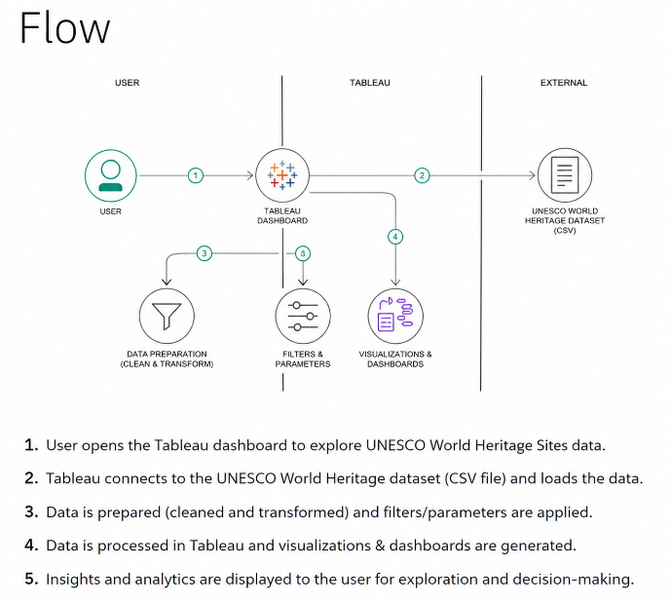
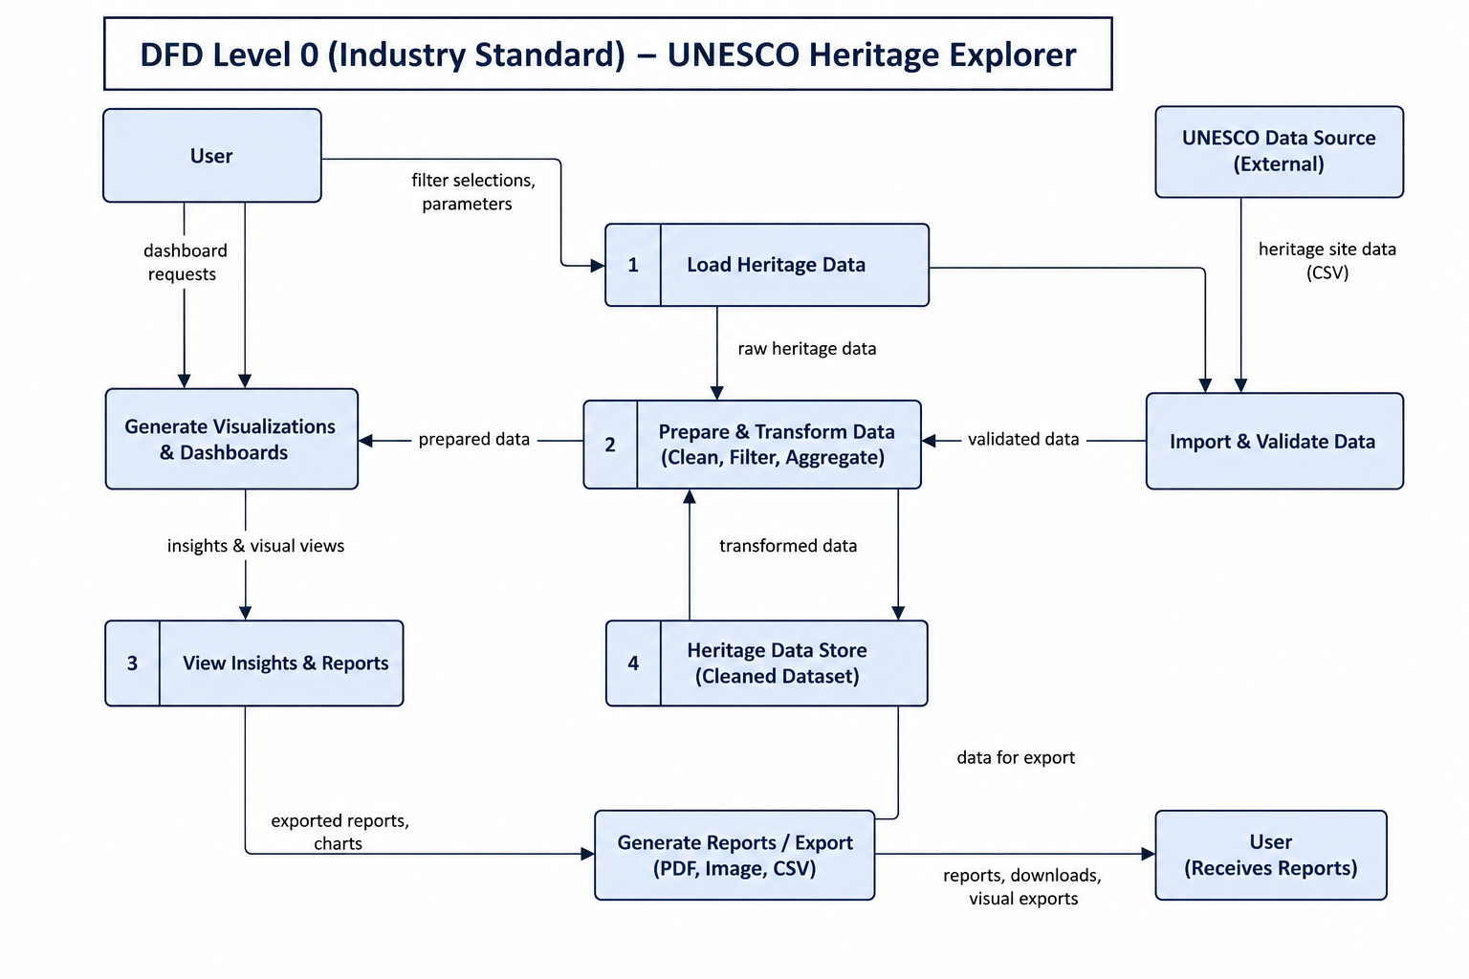

User Stories
Use the below template to list all the user stories for the product.
User Type | Functional Requirement (Epic) | User Story Number | User Story / Task | Acceptance criteria | Priority | Release
Data Analyst | Data Collection | USN-1 | As a data analyst, I can collect UNESCO World Heritage data from reliable sources for analysis. | UNESCO dataset is collected and available for processing. | High | Sprint-1
 |  | USN-2 | As a data analyst, I can load the collected dataset into Tableau for analysis. | Dataset is successfully loaded into Tableau Desktop. | High | Sprint-1
 | Data Preparation | USN-3 | As a data analyst, I can handle missing values in the UNESCO dataset to improve data quality. | Missing values are identified and treated correctly. | High | Sprint-1
 |  | USN-4 | As a data analyst, I can create calculated fields required for analysis and visualization. | Calculated fields are created successfully. | Medium | Sprint-1
 |  | USN-5 | As a data analyst, I can remove inconsistencies and duplicate records from the dataset. | Clean and consistent dataset is prepared. | High | Sprint-1
 | Data Visualization | USN-6 | As a user, I can view a bar chart showing UNESCO heritage site distribution by category. | Interactive bar chart is displayed correctly. | High | Sprint-2
 |  | USN-7 | As a user, I can view a pie chart representing heritage site categories. | Pie chart displays accurate category proportions. | Medium | Sprint-2
 |  | USN-8 | As a user, I can view a line chart showing heritage site trends over the years. | Trend analysis is displayed accurately. | Medium | Sprint-2
 |  | USN-9 | As a user, I can explore UNESCO heritage sites using an interactive world map. | Users can identify heritage sites by geographical location. | High | Sprint-2
Project User | Dashboard development | USN-10 | As a user, I can access an interactive Tableau dashboard to analyse UNESCO heritage information. | Dashboard is fully interactive with filters and visualizations. | High | Sprint-2
Project User | Story Development | USN-11 | As a user, I can explore Tableau Story points that explain analytical insights step by step. | Story points clearly present the complete analysis. | High | Sprint-2
Website User | Web Integration | USN-12 | As a user, I can access the Tableau Dashboard and Story through a Flask-based website. | Dashboard and Story are successfully embedded and accessible via the website. | High | Sprint-3
Website User | Project Information | USN-13 | As a user, I can read project details, objectives, and UNESCO information on the website. | Project information is displayed clearly with an attractive interface. | Medium | Sprint-3
Website User | Interactive Navigation | USN-14 | As a user, I can navigate between the Home, Dashboard, Storyboard, and About pages. | Navigation works correctly across all web pages. | Medium | Sprint-3

